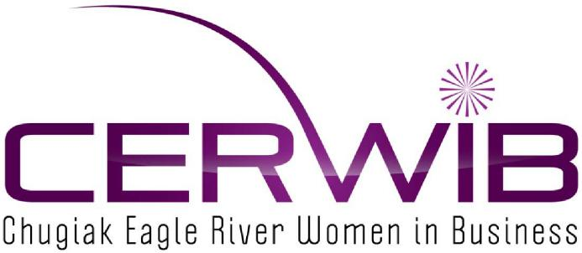
CHUGIAK-EAGLE RIVER WOMEN IN BUSINESS SCHOLARSHIP
HISTORY OF CHUGIAK-EAGLE RIVER WOMEN IN BUSINESS
The CERWIB Network helps women in business address the challenges of today’s business world through education, training and networking opportunities. Our members range from sole proprietors to large community based organizations.
SCHOLARSHIP INFORMATION - The maximum amount of a scholarship is One Thousand dollars ($1,000.00) per person.
SCHOLARSHIP GUIDELINES
- Must be a resident of South Central Alaska – proof of residency required
  - The area includes Cook Inlet, the Matanuska-Susitna Valley, the Kenai Peninsula, Prince William Sound, and the Copper River Valley.
  - The major city is Anchorage. Other towns include Palmer, Wasilla, Kenai, Soldotna, Homer, Seward, Valdez, and Cordova.
B. Applicants - any woman seeking additional education or training
C. Personal Statement of one page or less, to include:
a. Personal history – include last four years of your activities in:
- Employment/internship
- Community Service
- Description of career and educational goals and how you plan to achieve them
- How you plan to contribute to the betterment of your community upon completion of education.
D. Two letters of recommendation
E. Letter of Acceptance from intended accredited institution (college or vocational school) Enrollment in course of study which leads to a degree or certificate.
Scholarships shall be awarded without regard to race, national origin, age, or religious affiliation. Annual Applications and supportive documentation to be delivered no later than April 1st, to:

Deliver or mail to address:
Chugiak Eagle River Women in Business
PO Box 770856
Eagle River, Alaska 99577

Email: cerwib@gmail.com
CERWIB SCHOLARSHIP APPLICATION
Name: (last, first, middle)
Social security number (last 4 digits only)
Mailing address:
Home Phone: Message Phone:
Name and address of college or vocational school
Attached:

South Central Alaska – proof of residency:
The area includes Cook Inlet, the Matanuska-Susitna Valley, the Kenai Peninsula, Prince William Sound, and the Copper River Valley.
The major city is Anchorage. Other towns include Chugiak, Eagle River, Palmer, Wasilla, Kenai, Soldotna, Homer, Seward, Valdez, and Cordova.
Personal Statement
Two letters of recommendation
Letter of Acceptance from intended accredited institution (college or vocational school)
Enrollment in course of study which leads to a degree or certificate.

CERTIFICATION
I certify that all information provided is true and correct. I understand that any false, deliberate omissions or misleading information in this application may be grounds for rejection of this application and withdrawal of any award granted.
Applicant’s signature
Printed name: Date:
Annual Applications and supporting documents must be hand delivered or mailed no later than April 1st to:
Deliver or mail to address:
Chugiak Eagle River Women in Business
PO Box 770856
Eagle River, Alaska 99577

Email: cerwib@gmail.com

